Benin

## Population Data

The data set shows the political stability estimate of the country each year.

## # A tibble: 23 x 5  
## country iso3c date population popCategory5  
## <chr> <chr> <dbl> <dbl> <chr>   
## 1 Benin BEN 1996 6094259 small   
## 2 Benin BEN 1997 6281639 small   
## 3 Benin BEN 1998 6470265 small   
## 4 Benin BEN 1999 6664098 small   
## 5 Benin BEN 2000 6865951 small   
## 6 Benin BEN 2001 7076733 small   
## 7 Benin BEN 2002 7295394 small   
## 8 Benin BEN 2003 7520555 small   
## 9 Benin BEN 2004 7750004 small   
## 10 Benin BEN 2005 7982225 small   
## 11 Benin BEN 2006 8216897 small   
## 12 Benin BEN 2007 8454793 small   
## 13 Benin BEN 2008 8696921 small   
## 14 Benin BEN 2009 8944708 small   
## 15 Benin BEN 2010 9199259 small   
## 16 Benin BEN 2011 9460830 small   
## 17 Benin BEN 2012 9729248 small   
## 18 Benin BEN 2013 10004588 small   
## 19 Benin BEN 2014 10286842 small   
## 20 Benin BEN 2015 10575952 small   
## 21 Benin BEN 2016 10872067 small   
## 22 Benin BEN 2017 11175204 small   
## 23 Benin BEN 2018 11485048 small

## # A tibble: 23 x 5  
## country iso3c date popGrowth popGrowthCat5   
## <chr> <chr> <dbl> <dbl> <chr>   
## 1 Benin BEN 1996 3.15 high growth rate  
## 2 Benin BEN 1997 3.03 high growth rate  
## 3 Benin BEN 1998 2.96 high growth rate  
## 4 Benin BEN 1999 2.95 high growth rate  
## 5 Benin BEN 2000 2.98 high growth rate  
## 6 Benin BEN 2001 3.02 high growth rate  
## 7 Benin BEN 2002 3.04 high growth rate  
## 8 Benin BEN 2003 3.04 high growth rate  
## 9 Benin BEN 2004 3.01 high growth rate  
## 10 Benin BEN 2005 2.95 high growth rate  
## 11 Benin BEN 2006 2.90 high growth rate  
## 12 Benin BEN 2007 2.85 high growth rate  
## 13 Benin BEN 2008 2.82 high growth rate  
## 14 Benin BEN 2009 2.81 high growth rate  
## 15 Benin BEN 2010 2.81 high growth rate  
## 16 Benin BEN 2011 2.80 high growth rate  
## 17 Benin BEN 2012 2.80 high growth rate  
## 18 Benin BEN 2013 2.79 high growth rate  
## 19 Benin BEN 2014 2.78 high growth rate  
## 20 Benin BEN 2015 2.77 high growth rate  
## 21 Benin BEN 2016 2.76 high growth rate  
## 22 Benin BEN 2017 2.75 high growth rate  
## 23 Benin BEN 2018 2.73 high growth rate

## Population trend

The plot shows the population trend of the country.

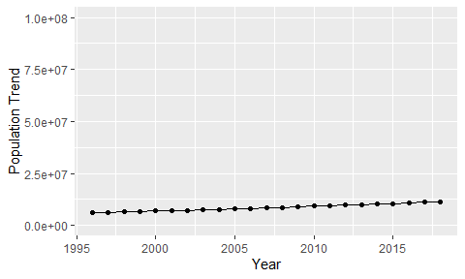

Political Stability Trend

# Population growth graph

The plot shows the population growth rate trend of the country.

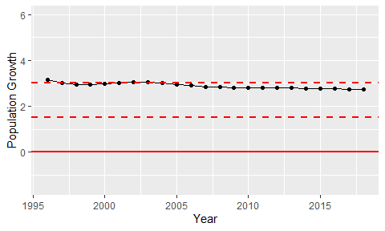

Population Growth Trend